FACULTY PROFILE
Name | THOLLA RAMA SUNKANNA | 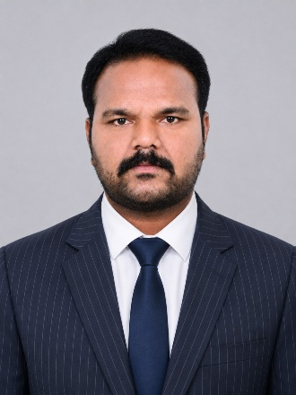
Department | PHYSICS
Designation | LECTURER
Date of Appointment | 07.06.2018
Date of Birth | 18.03.1986
Contact Number | +919052255621
Email Id | thollaramasunkanna@gmail.com
Academic qualifications:
Qualification | Name of the University | Year of passing
Ph. D | SV University | Studying
M.SC/M.A/M.COM | SV University | 2010
Others Qualifications (NET/SET etc.), if Any | AP-TS SET – 2014 (OU)  UGC CSIR NET – 2017 | 2014  2017
Experience Details:
Designation | Name of the Institution, Place | From | To
Lecturer | Government Degree College: Gummalakshmipuram | 07.06.2018 | 28.09.2022
Lecturer | Government Degree College: Salur | 29.09.2022 | 02.08.2023
Lecturer | S.V.A Government College (M); Srikalahasti | 03.08.2023 | 10.07.2026
Lecturer | Government College For Men:: Kurnool | 11.07.2026 | Till date
Total Teaching Experience: P.G Classes: 0 Years
U.G Classes: 8 Years.
Research Experience Including Years spent in M.Phil/Ph.D: 2 Years
Fields of Specializations under the subject/Discipline:
a. Condensed Matter Physics.
b.
List of research Publications/Books:
Title of the Paper | Journal | Year of Publishing | UGC CARE/SCI/SCOPUS etc.
Spectroscopic, photometric, and radiation shielding studies of europium-activated red-emitting magnesium borosilicate glasses | Elsevier | 2026 | UGC Care
List of Projects Completed:
Title of the Project | Sponsoring Agency | Major/Minor | Total Grant Received | Year of Completion
NIL
List of OC/RC/TOTs/FDP/MOOCS/ARPIT Attended:
Title of the course | Type of the Course (FDP/RC Etc.) | Duration | Organized by
Child Protection & Child Rights in Disasters and Emergencies | Training of Trainers | 4 days  (14 to 17 Nov -2023) | CCDRR - NIDM
Microsoft Diversity Skilling Program | Online Facilitator Training Program on AI Fluency,Digital Productivity, and Employability Skills | 5 days (18-12-2023 to 22-12-2023). | APITA
One Day Training of the Trainers Programme (ToT) on UNESCO-MGIEP SEEK & SEL Certificate Course | SEEK & SEL Certificate Course | 01 day (23.01.2024) | UNESCO - MGIEP
Online Refresher Course in "HEALTH  MANAGEMENT" by MMTTC | RC | 20.08.2025 to 02.09.2025 | UGC MMTTC - SV University, Tirupati
Awareness Programme on Artificial Intelligence Through Online | FDP | 03.11.2025 to 13.11.2025 | CCEAP Mangalagiri
One week skill development programme on operation and maintenance of laboratory instruments | FDP | 15-19 Dec 2025 | Department of Physics SV Univeristy
Faculty Development Programme on Applications Artificial Intelligence Through Online | FDP | 23.02.2026 to 13.03.2026 | CCEAP Mangalagiri
Co-Curricular, Extension and Professional Development Related Activities:
S.No | Name of the Activity | Details
1 | Student related Co- Curricular, extension and field-based activities (such as extension work through NSS/NCC and other channels, Cultural activities, subject related events and counseling.
2 | Contribution in corporate life and management of the department and participation in academic and administrative committees and responsibilities and Professional Development.
Awards/ Achievements: Please give details of any other credentials, significant contributions, awards received:
S.No | Name of the Award/Achievement | Date of Receiving
1 | Nil

